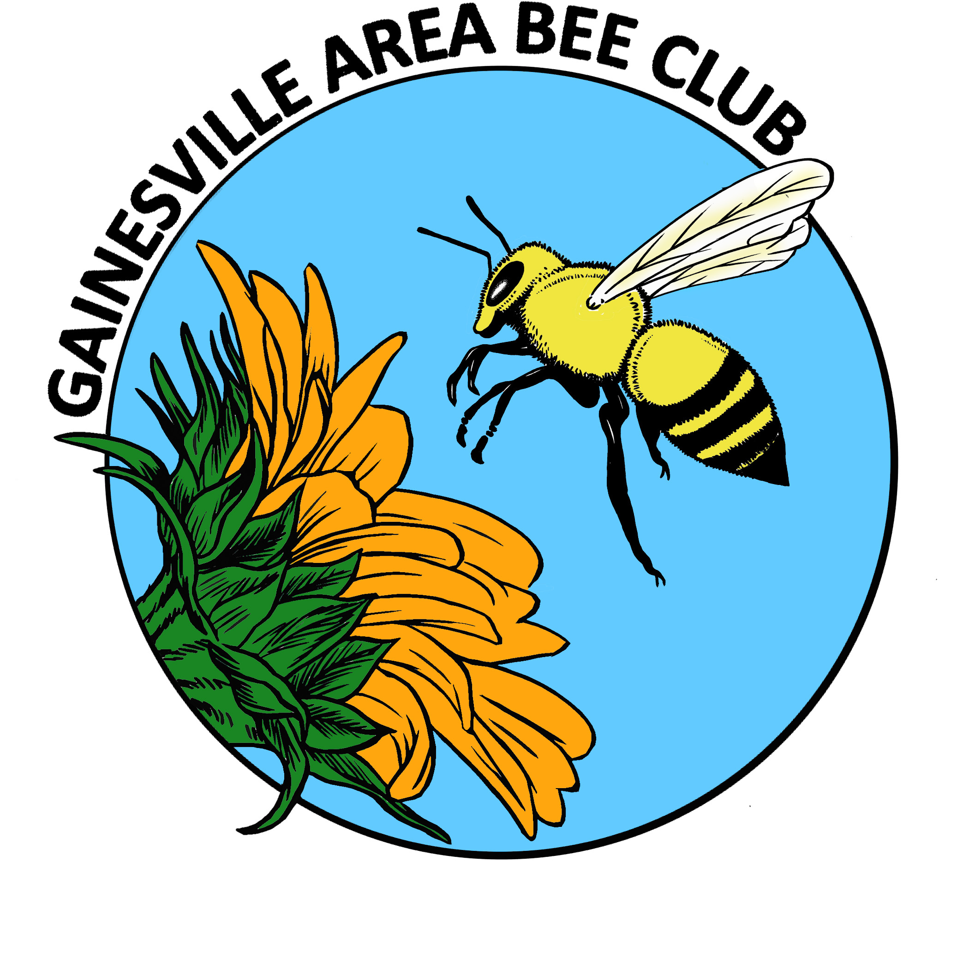
GAB EC AGENDA
NOVEMBER 2013
No EC meeting.
Kim and Janice to work on website with Andrew.
Next month:
American Federation of Beekeepers letter/invitation
General Meeting Announcements
*Nominations; Election next month
Current Nominations
President Elect NONE
Treasurer Susan Harris
Communications Secretary Kim Harris
Recording Secretary NONE
FSBA Representative Richard Bias
Raffle Organizer
*Lubee Bat Festival report
*Fall Picnic Report
*SFCC Hobby Beekeeping Course
*Show observation hive
*Beekeeping Rule 5B-54
They include the elimination of the neighbor approvals for obtaining a special permit to register bees if the beekeeper cannot comply with the conditions of the Beekeeper Compliance Agreement (BCA). Portions of the BCA were also updated to include clearer colony densities on land larger than an acre. Colony densities under the BCA include the increases in swarm season to double the number of acceptable colonies for a 60 day period. The final version will still require the beekeepers whose apiaries are on land not zoned as agricultural to sign the Beekeeper Compliance Agreement upon their annual inspection or alternatively request a special permit.
*Bee Buddies
*Next month potluck

