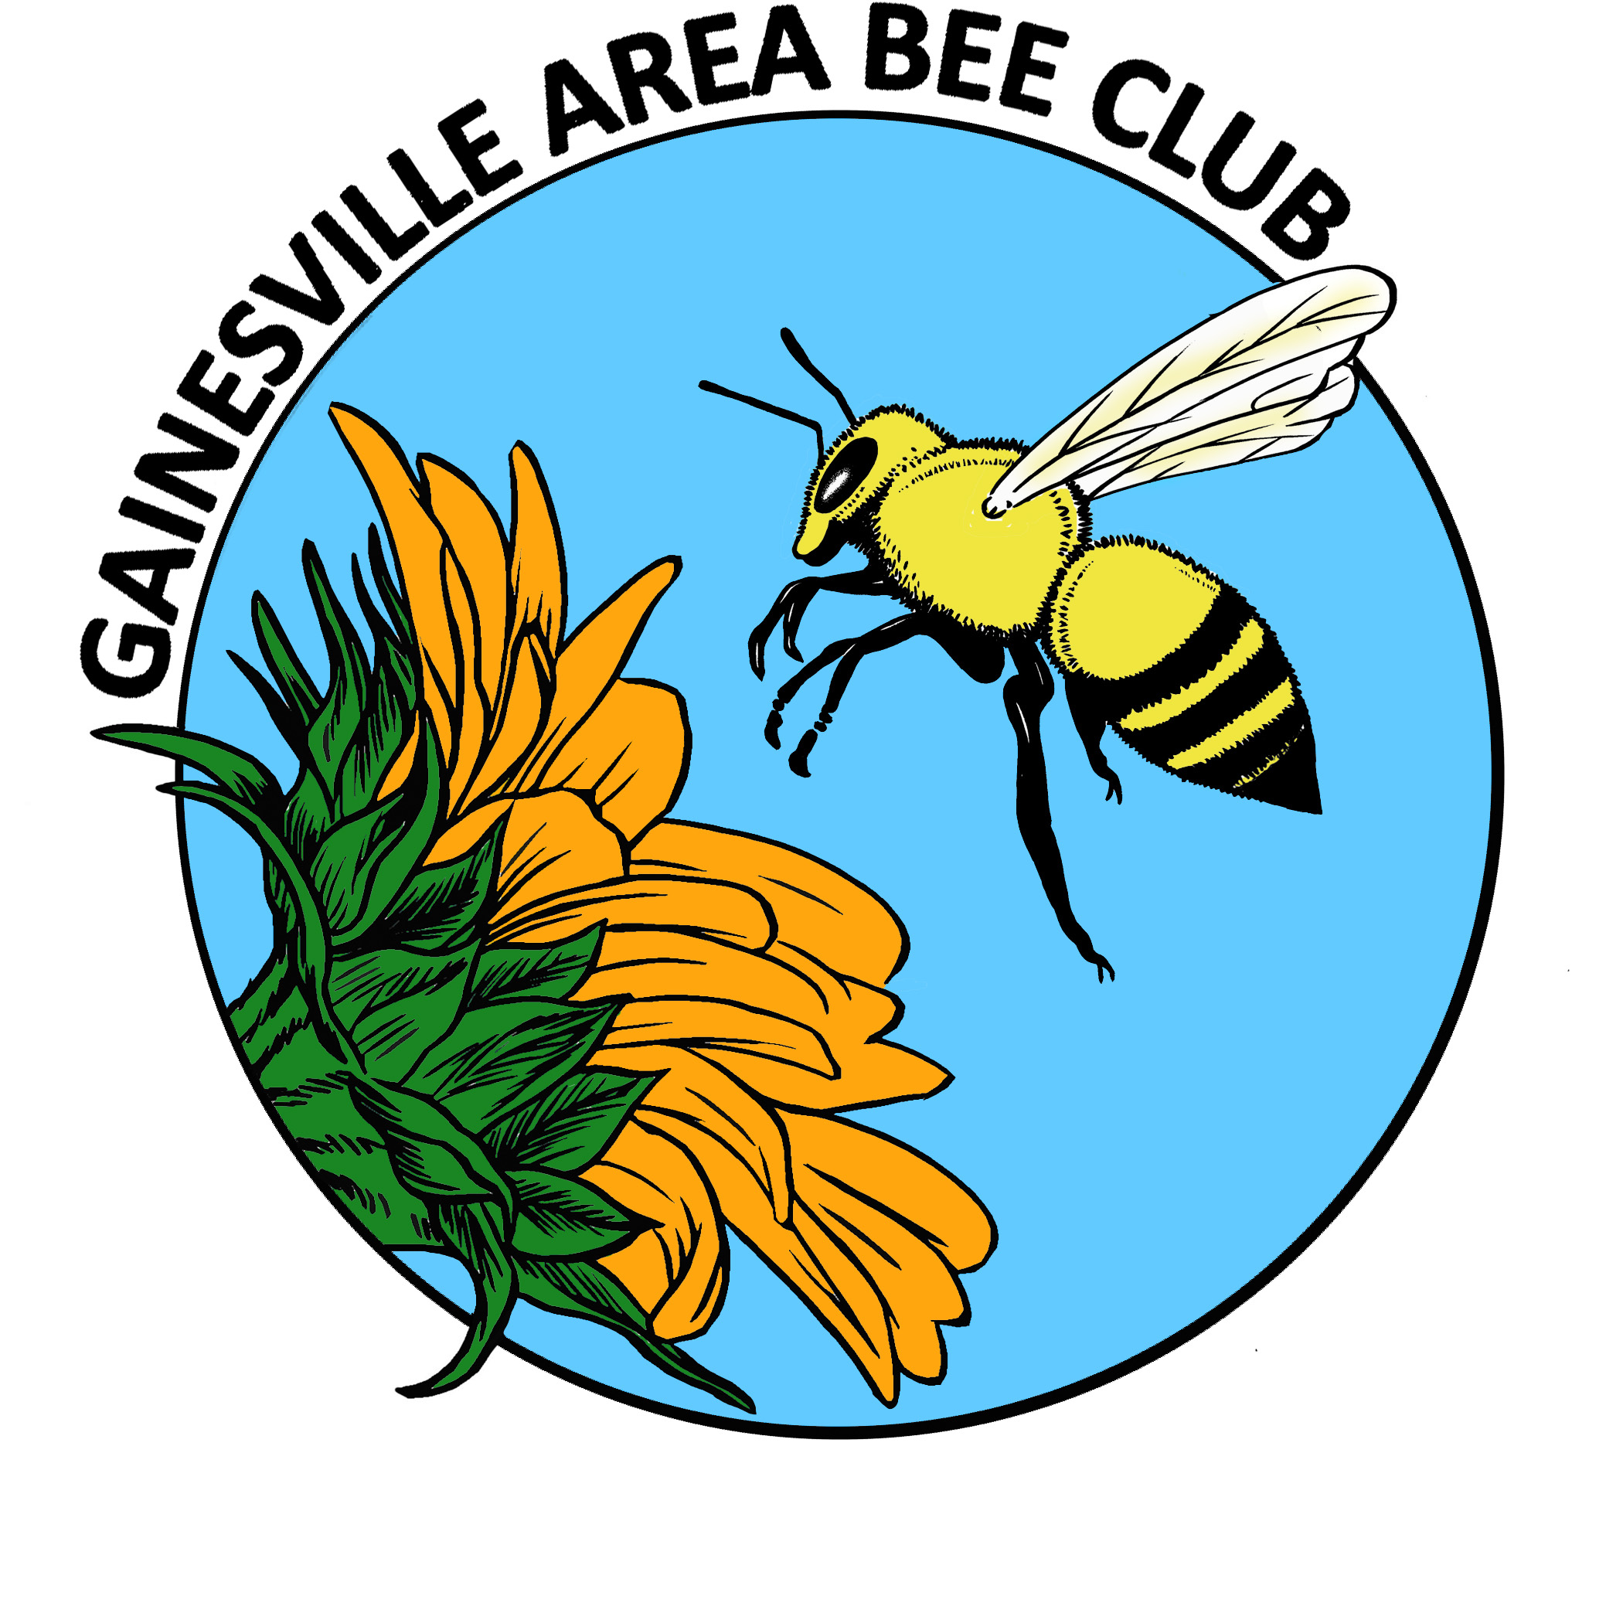
GAB Executive Council Agenda
December 2013
No EC Meeting.

General Meeting Announcements
*Nominations; Election
Current Nominations
President Elect NONE
Treasurer Susan Harris
Communications Secretary Kim Harris
Recording Secretary NONE
FSBA Representative Richard Bias
Raffle Organizer Cecelia Young
Webmaster Andrew Smith
*Hives needed for research
Charles Stuhl, PhD
Entomologist
USDA-ARS, CMAVE
1700 SW Drive
Gainesville, FL 32608
352-374-5704
charles.stuhl@ars.usda.gov
*Buying nucs in bulk for spring
*Dadant 150 year anniversary; Best Extraction Story Contest http://www.dadant.com/contest
*Bee Buddies
*Bees in the News
*Nature Conservancy Article
*Bee from Museum of Science in Boston
*Questions? Hive news?

