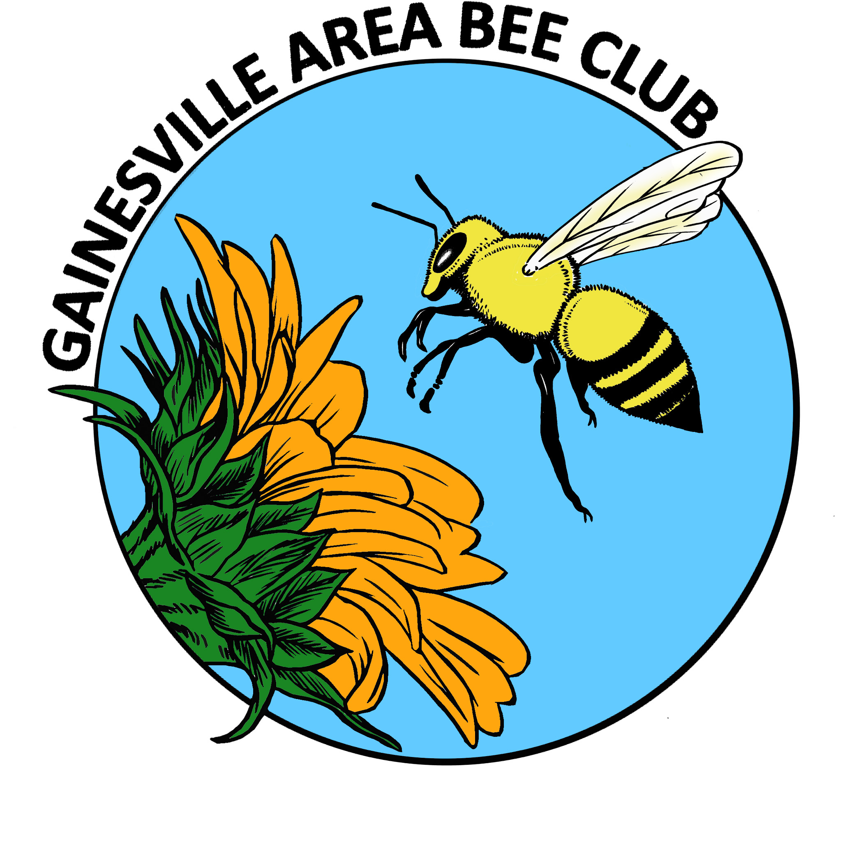
GAB Executive Council Minutes
January 2014

TREASURY REPORT
$1818.60 Bank Balance

OLD BUSINESS
*Recognition of new officers:
- Janice Garry, President; Susan Harris, Treasurer; Kim Harris, Communications Secretary; Archie Mathews, Recording Secretary; Richard Bias; Florida Beekeepers Association representative
*Website; Kim & Janice met for discussion and development

NEW BUSINESS
*Promotional materials will be developed for our community outreach goals.
- A QR code that will be linked to our website, will be added to the back of our new business cards (Kim Harris). NOTE: QR code should have an edge for accurate reading.
- A GABC flyer will be developed
*T-Shirts with logo will be designed. Different styles of shirts, such as v-neck and tank tops will be explored.
*A focus on supporting new members and new beekeepers is a strong goal:
- Bee Buddy program will continue to be developed as a broad concept of helping fellow beekeepers by matching skills, interests and needs. A Bee Buddy hotline or chat feature on the website will be explored.
- New member packet will be developed that may include a copy of the Beginning Beekeeping disc and information for a video of the basics of inspection. The disc, originally created by Archie, needs minimal updating.
- The EC unanimously voted to offer the UF Honeybee Club free membership to officers and a discount to club members. A $5.00 annual membership will be offered to all UF HB members.
*Gary advised us of the Bee Informed national program that is a chat forum. http://beeinformed.org/
*Creation of a library was discussed. The consensus seemed to be that a hard-copy library may be difficult for finding storage, transport of books and having a librarian to organize check-out and return of books. If we decided to go that route, Gary offered to donate books. Another option is a thorough list of online resources with links on our website.
*Bee College will be in St. Augustine on March 7-8, Friday - Saturday. The scholarship will include $100.00 for expenses. Raffle tickets are $5.00 each or six for $20.00.
UPCOMING EVENTS
*Kanapaha Spring Festival 3/22 – 3/23. Susan Harris will organize the GABC booth. Cindy and Duane Diehl offered to bring their observation hive in addition to the GABC observation hive to improve visibility to booth visitors.

General Meeting Announcements
*Honeytasting presentation and samples by Cecelia Young.

*A honey jar doorprize was given away.

*BEES IN THE NEWS; An article from “Nature Conservancy” was shared.

*COMMUNITY OUTREACH
Greenberry Taylor’s journalism project: http://gbtufjournalismblog.wordpress.com/gainesville-beekpeeing-beeswax-and-a-little-exrta/

