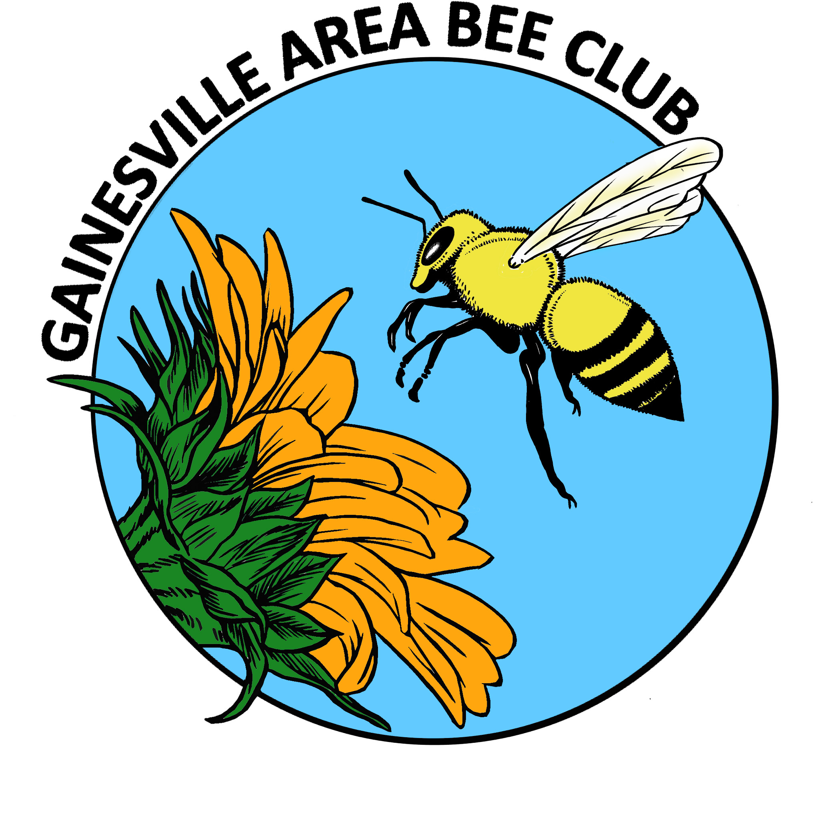
GABC Executive Council Agenda
February 2014
TREASURERY REPORT
OLD BUSINESS
- President elect needed
- Membership renewals; x2 people to staff membership table
NEW BUSINESS
- TY Notes for speakers
- Purchase nuc for observation hive?
- Change March meeting from Mar 6 to Mar 13 to accommodate Bee College?
- Group nuc purchase pick up and delivery
- Hive handling workshop(s)
- FSBA in Gainesville Nov 31- Oct 1
- Prison beekeeping course

UPCOMING EVENTS
- Kanapaha
- Bee College

General Meeting Announcements
*President Elect needed
*Lost and Found; gold “Toasted Mango Café” cap; green folding chair from picnic @ Gary’s home
*RAFFLE
*BEES IN THE NEWS
- North American Pollinator Protection Campaign call for research
- Maryland visiting beekeeper report on bees
*COMMUNITY OUTREACH
- Prison beekeeping program; Don Hicks
*BEE BUDDIES; Who needs a helping hand?
*UPCOMING EVENTS
- Bee Yard Locations Form
- Kanapaha Spring Garden Festival
Volunteers needed
Bees for observation hive needed

