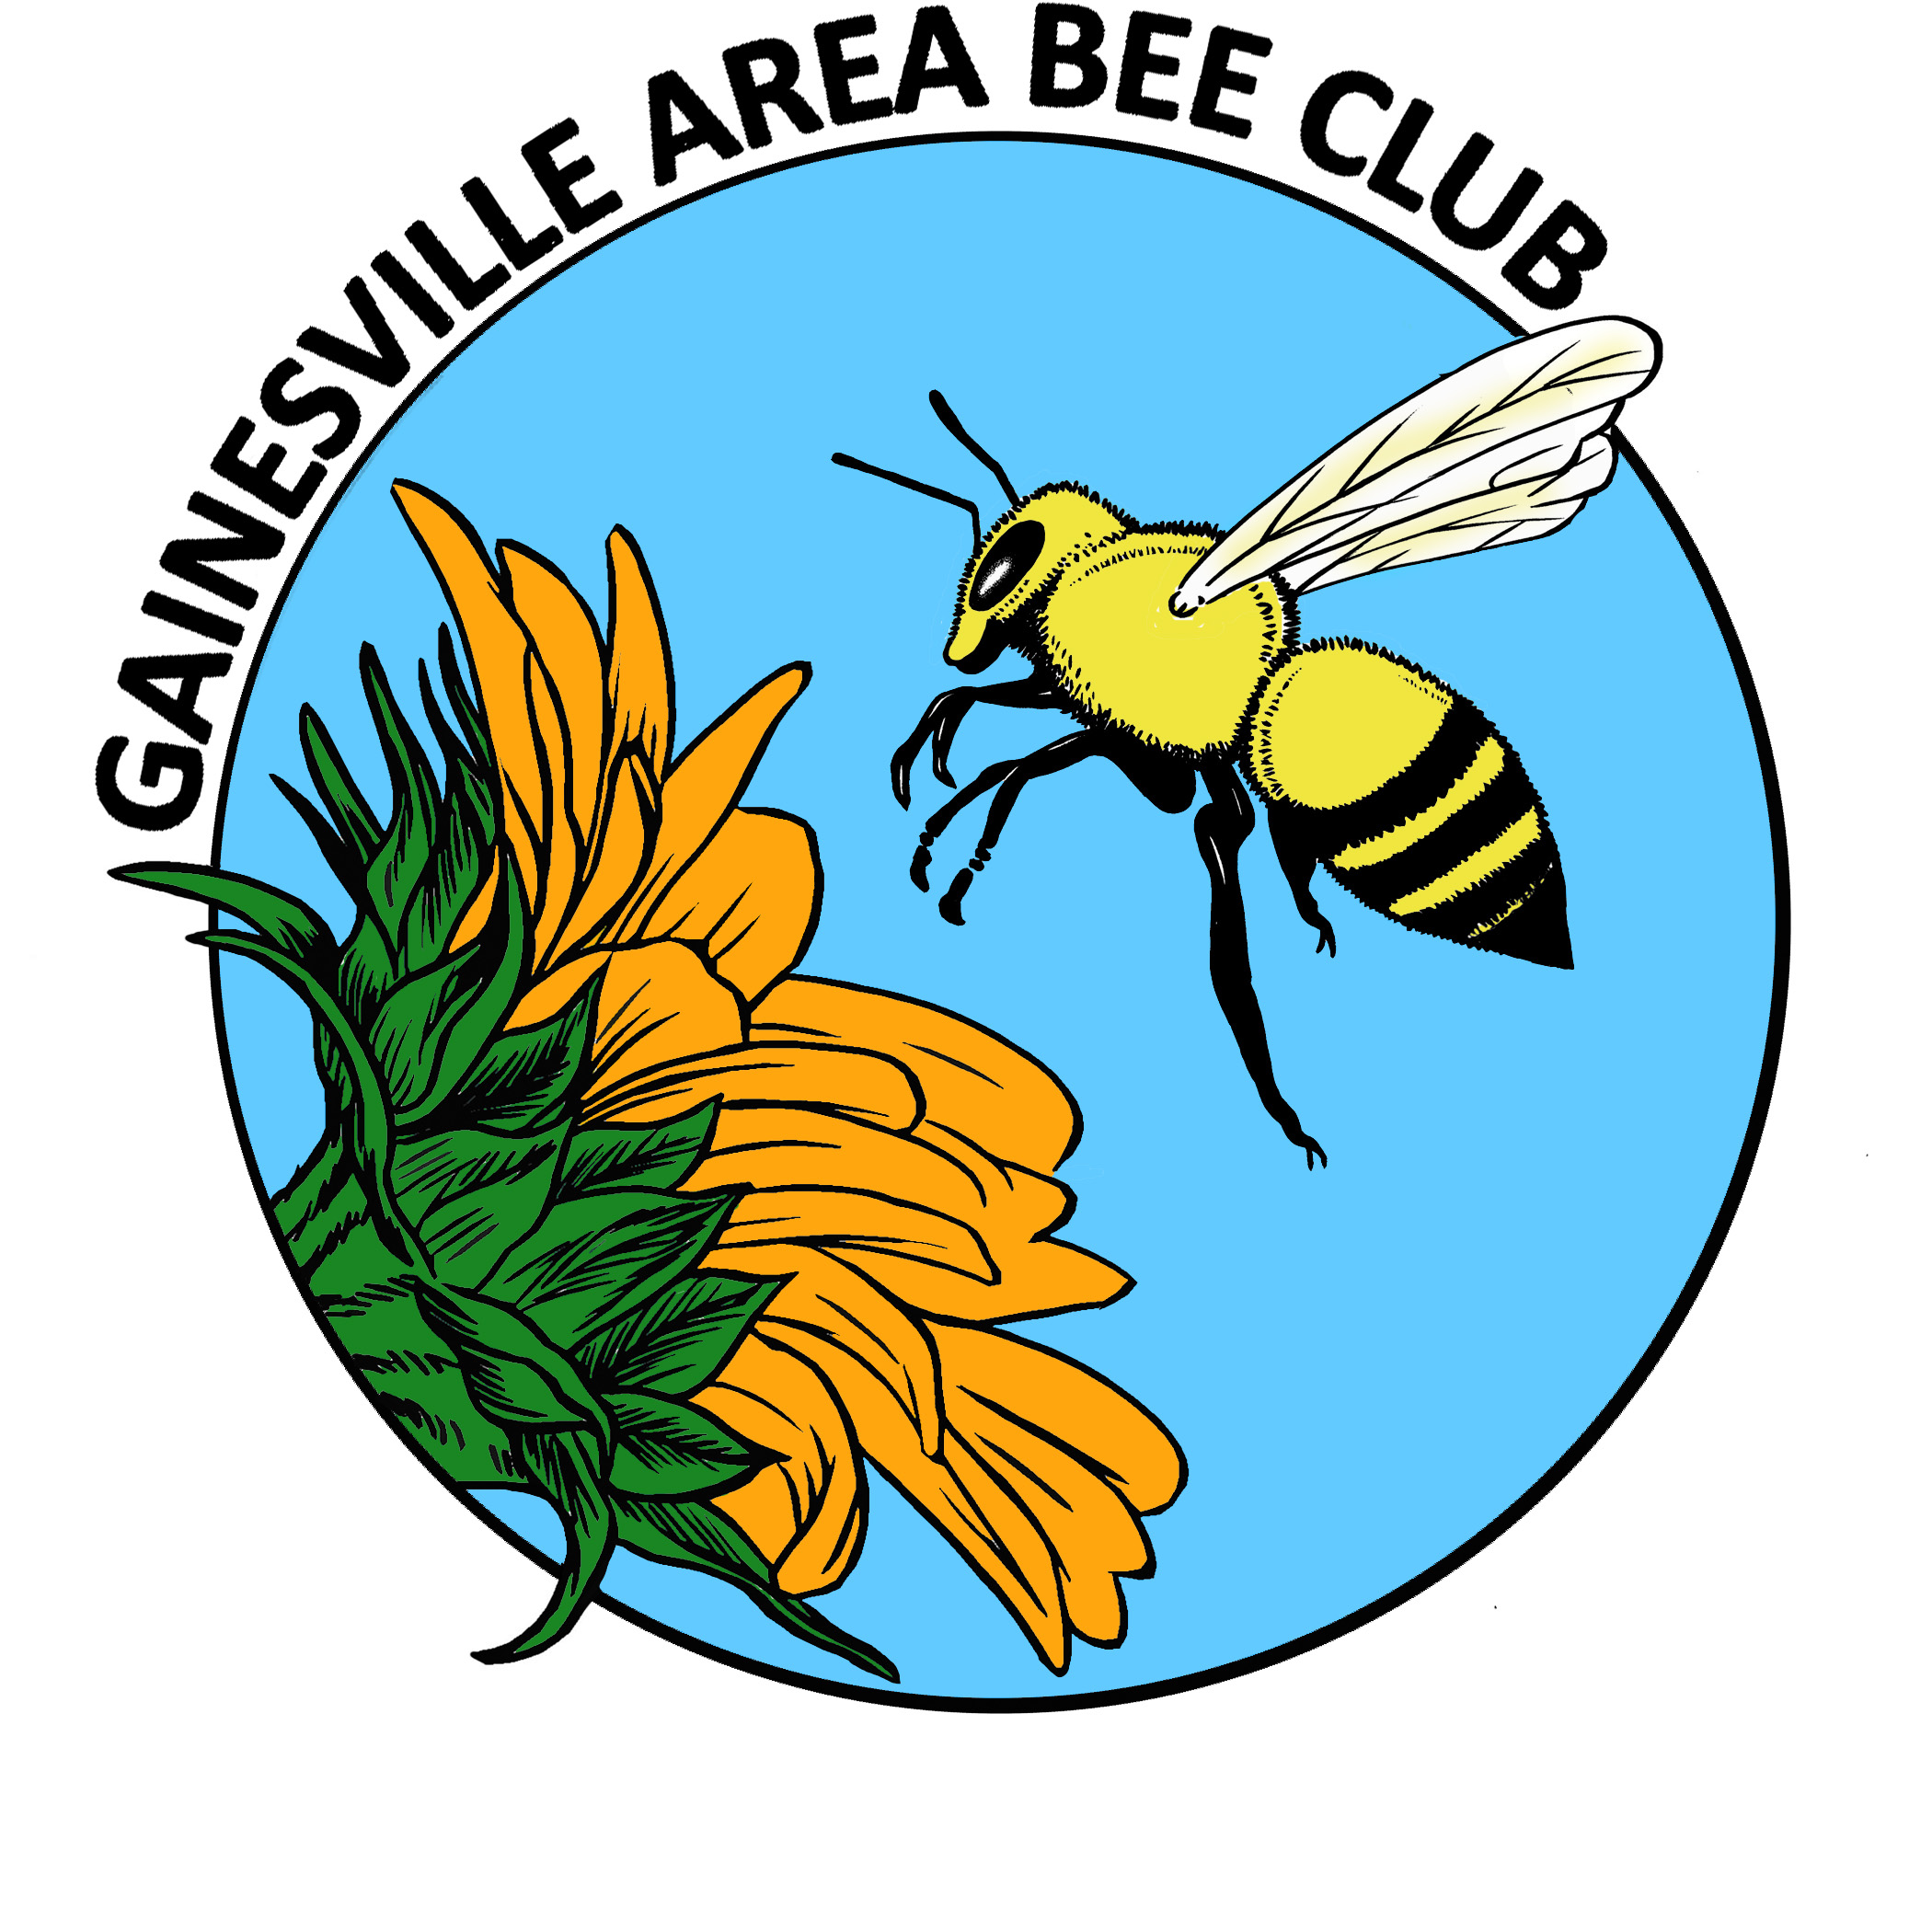
GABC Executive Council Agenda
March 2014

TREASURER REPORT
$3377.86 balance in banks
$1910.00 for pre-ordered nucs
$1467.86 available balance
Lost $60.00 on raffle for Bee College tuition/spending money. Suggestion to conduct raffle over longer period.
Raffle tuition, give spending money if we get enough from raffle.

OLD BUSINESS
- Membership renewals; status report
- Dues not paid by March will be dropped from email list.
- Send email to group to notify them that they will be dropped
- Roughly 80 current members.
- Apiary inspectors are to be listed as honorary members.
- Group nuc purchase; pick up & delivery
- 18 nucs ordered for club members, 1 for the club
- Meet at Entomology parking lot distribute.
- No date for pickup yet
- Remind members to have woodenware ready and site located.
- FSBA in Gainesville Nov 31-Oct1
- Looking for a site
- Needs to be minimal cost, FSBA is non-profit organization
- Research center grant going to Legislature
- Janice willing to stay on for another year as President
- Needs another year to get things organized.
- Need to have events scheduled in advance.
NEW BUSINESS
- Welcome Carlos Quijada-Silva!
- Monthly EC meeting at 6pm – always meet before regular meeting.
- Prison beekeeping course
Archie to review course syllabus
Carlos
Richard
Ken
- Old display board, Cecelia will take.
- New display board with new logo has been created.
- Janice will store new display board.

- Spring field trip to see wildflowers
- Dates? Early May?
- Need someone to organize.
- T-shirts & fashion wear
- Ray – make a wi-fi connection available for members at meet
UPCOMING EVENTS
- Kanapaha
- Will be outside, will need tent, table, observation hive.
- Janice has equipment stored at her house.
- Need a few more people
- Will call for more volunteers at general meeting.
- Will need 2 tables
- Question re: event liability insurance. Susan is checking into it.
Kim-has used Ellett Insurance
Check with FSBA for insurance information

General Meeting Announcements
*MEMBERSHIP RENEWALS; update
*RAFFLE
*BEE COLLEGE REPORT(S)
- New members?
- New display board
- Learning highlights
*Vote; Janice to serve this year and next?
*Bee Club nuc ordered; Oakview Co-op to manage bees
*FSBA update
*COMMUNITY OUTREACH
(Prison program)

*BEE BUDDIES - Lending a helping hand
- Natasha assisted with hive strengthening
- Tomas has a place to keep his hive – yippee!
- Anybody else?
*UPCOMING EVENTS
- May 10th; sshhhh! Diane Van Cleef BD bash!
- Bee Yard Locations Form
- Kanapaha Spring Garden Festival
Bees for observation hive needed
- Extension Office classes – FREE! 352-955-2402. Visit http://alachua.ifas.ufl.edu/calendar.shtml

