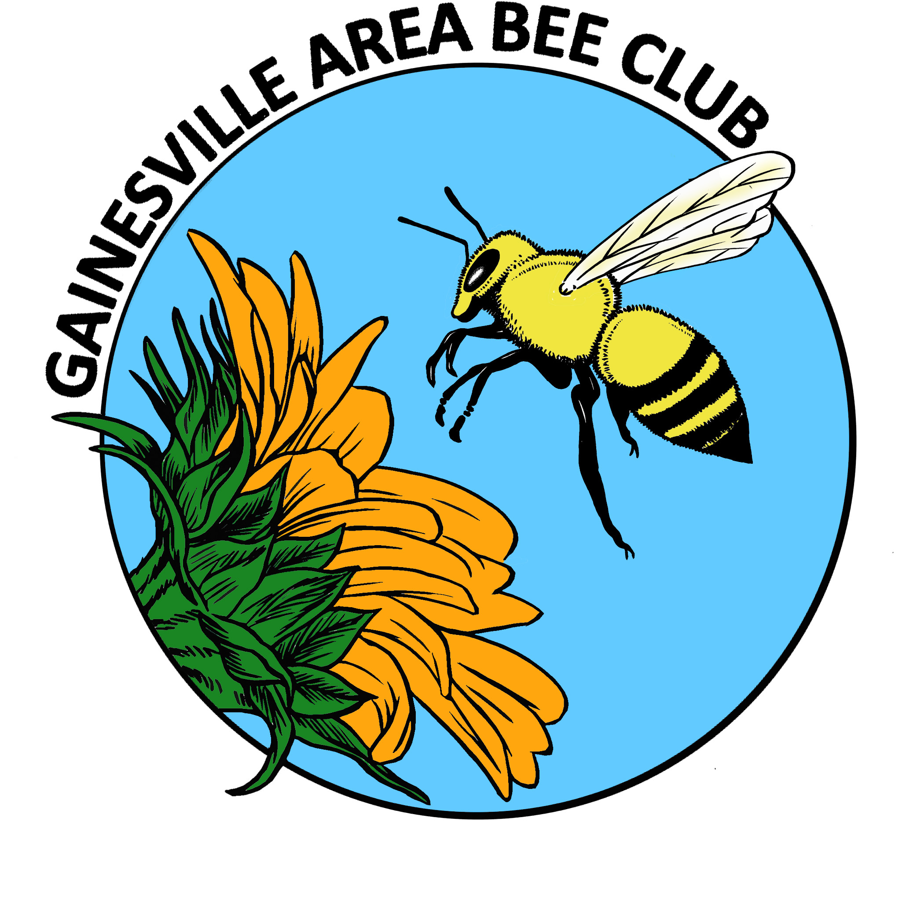
GABC Executive Council Agenda
April 2014

TREASURER REPORT

OLD BUSINESS
- Looking for a site-no site designated yet.

- Prison beekeeping course update; Richard, Carlos, Ken, Archie
- Syllabus reviewed?-Yes. Ken and Archie will coordinate.

- Wifi update; Janice –no update.

- Liability insurance update; Susan-Not an easy issue. Do we need general liability or event insurance?
Has talked with an insurance agent in Boca Raton.
Homeowner insurance does not cover honeybees.
We are covered when we are at the Extension office.
Checking with American Insurance that 4H uses.
FSBA has insurance, will check with FSBA Treasurer.
We only do 2-3 events per year that are not connected with UF where we bring bees.
Different situation for beekeepers than the general public.
Susan has taken class to be certified to use Epipens.
Suggestion that we have a presentation on insurance for beekeepers.
- Observation hive modifications-hive designed for cooler climate. Bees got too hot at Kanapaha. Suggestions needed on modifications. Suggestion (Stephen Cutts) to bore some 1 inch holes in the ends, put screen on from the inside, louvers or screens on the outside, add a second screen to the bottom, add higher cleats. Members using the observation hive need to be aware of how it is supposed to be setup.

- Verify volunteer for hands-on hive inspection & their zip codes. Enter on post on website.
NEW BUSINESS
- Spring field trip to see wildflowers May 3;
- T-shirts & fashion wear
- Travis Mitchell; Community Growers-have inherited some beekeeping equipment, group needs assistance.
- Earth Day community event April 19, Sat 9am – 1pm – Karen Epple, event at Bo Diddley Plaza on 4/19 (Easter weekend) may go with brochures if someone wants to, no time to put together a real presentation.
- GABC hive – pay for brood box set?

General Meeting Announcements
Treasurer report
$3484.26 in account, $1910.00 committed to nuc purchase. Available funds $1574.26

nucs to be ready on april 12th, 18 nucs ordered for members. pickup to be at entomology parking lot, bring your hive to transfer frames & bees into.
*RAFFLE
*FSBA update
- Richard-no update
- http://floridabeekeepers.org/, Florida State Beekeepers Association website. On their home page is a "membership" tab. After clicking on this tab, it will give you all the necessary instructions to sign up.
- May meeting Malcolm Sanford to talk about FSBA and sign-up for membership will be available.
- Link to FSBA website to get full text of Tax Watch recommendation.
*BEES IN THE NEWS
- Alligator article about the possible new research facility. An article was in the Record also.
*COMMUNITY OUTREACH
- Report on Kanapaha
THANK YOUS to volunteers!
Lots of visitors, observation hives very popular. Thanks to Cindy and Duane for bringing their observation hive also.
THANK YOU to Jenny & Dan for bee frame!
Tent & observation hive were purchased with club dues.
Club nuc will be picked up on 4/12
- Prison beekeeping class; Richard, Carlos, Ken & Archie
Still coordinating setup/dartes of classes.
- Travis Mitchell; Community Food Project Coordinator – Florida Organic Gardens,
Porter’s Community Farm & Garden
Has had some beekeeping equipment donated. Needs volunteers to help with setting up beekeeping project.
Alachua Bee Club will match any money that GABC will donate.
Suggestion to involve the UF Beekeeping Club.
*BEE BUDDIES - Lending a helping hand
- Karen Epple @ Oakview Neighbors Co-op
About ready to get bees.
- Who needs a helping hand?
*UPCOMING EVENTS
- May 11, Sunday; Surprise BD party for Gary’s wife, Diane.
Non-bee event – all birthday fun for Diane.
- Bee Yard Locations Form
State is attempting to map locations of all bee yards. Will bring forms.

- Extension Office classes – FREE! 352-955-2402. Visit http://alachua.ifas.ufl.edu/calendar.shtml
4/19 – Hive inspection is next class. You do not have to attend all of the classes, you can pick and choose.
- April meeting will be hive inspection and interesting phenomena. Send pictures to Janice or bring frames that you would like to discuss.
- Question about why some beekeepers are not listed on the FDACS website.
Call inspection office if there are concerns, or if bees seem to be in the wrong place.
ANNOUNCEMENTS
Karen Epple - Earth Day event at the Bo Diddley Plaza on April 19th. Would like volunteers, information.
PROGRAM
HONEY BEE BIOLOGY – Stephen Cutts
ADJOURNMENT

