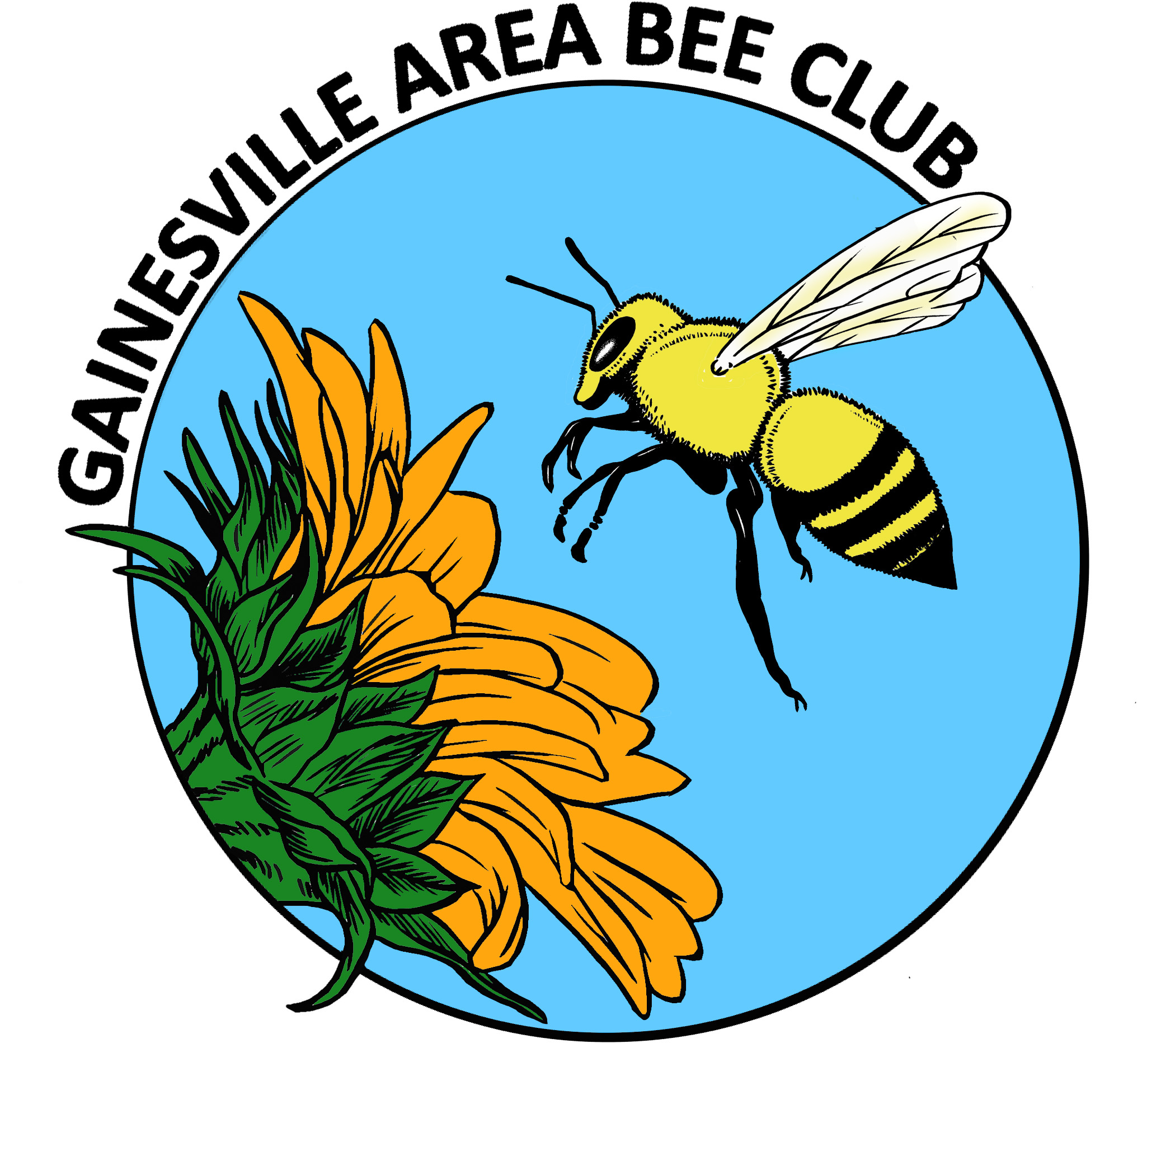
GABC Executive Council Agenda
May 2014

TREASURER REPORT
OLD BUSINESS
- Prison Beekeeping Course; Archie, Ken, Richard & Carlos

- Wifi update - it’s complicated! Poll membership to see who would use it.

- Liability insurance update; Susan-Not an easy issue. Do we need general liability or event insurance?
Has talked with an insurance agent in Boca Raton.
Homeowner insurance does not cover honeybees.
We are covered when we are at the Extension office.
Checking with American Insurance that 4H uses.
FSBA has insurance, will check with FSBA Treasurer.
We only do 2-3 events per year that are not connected with UF where we bring bees.
Different situation for beekeepers than the general public.
Susan has taken class to be certified to use Epipens.
Suggestion that we have a presentation on insurance for beekeepers.
- Observation hive modifications- Dan & Jenny
- Verify volunteer for hands-on hive inspection & their zip codes. Enter on post on website.
- Travis Mitchell; Community Growers; update?
NEW BUSINESS
- Spring field trip to see wildflowers May 3;
- T-shirts & fashion wear
- Travis Mitchell; Community Growers-have inherited some beekeeping equipment, group needs assistance.
- Earth Day community event April 19, Sat 9am – 1pm – Karen Epple, event at Bo Diddley Plaza on 4/19 (Easter weekend) may go with brochures if someone wants to, no time to put together a real presentation.
- GABC hive – pay for brood box set?

General Meeting Announcements
Treasurer report
*NUCS Delivered!
- Club Nuc @ Oakview Neighborhood Nectar
*Raffle; Cecelia
*FSBA update

*BEES IN THE NEWS
- Research facility update?
*COMMUNITY OUTREACH
- Prison beekeeping class; Richard, Carlos, Ken & Archie

- Travis Mitchell; Community Food Project Coordinator – Florida Organic Gardens,
Porter’s Community Farm & Garden
*BEE BUDDIES - Lending a helping hand
- Will and John
- Who needs a helping hand?
*UPCOMING EVENTS
- May 3, Saturday; Wildflower visit and picnic at Janice’s house
- May 11, Sunday; Surprise BD party for Gary’s wife, Diane.
Non-bee event – all birthday fun for Diane.
- May 17, Saturday; Master Gardner’s Sale
ANNOUNCEMENTS
PROGRAM
Malcolm Sanford
Florida State Beekeepers Asc; purpose and how to contributre
Hive Inspections
ADJOURNMENT

