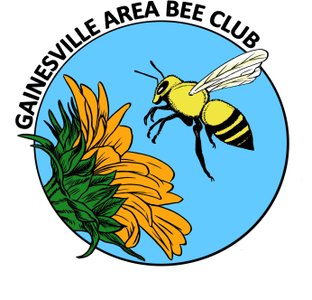
GABC Executive Council Minutes
NO EC MEETING THIS MONTH (the following are from Sept 2014)
October 2014

TREASURER REPORT
OLD BUSINESS
- ON HOLD; Liability insurance
- Prison Beekeeping Course; teach again? (On hold-wait to hear from Ken & Cecelia)

- NEW BUSINESS
- 2015 calendar;
Change January meeting to 1/8
Revisit July & August meeting/no meeting as we get closer.
- Website report; Kim!
Website updated, need pictures to post on the site.
Contact page-add form to fill out to ask questions, forward to someone to answer. Need common email address to send to, have officers, etc. check every day.
Submit articles to Kim to post on the club news page.
Kelly Rogers-attends meetings, professional photographer, takes bee pictures.
Add links to honeybee lab, FSBA
- Gary’s Honduras student and fundraisers – paperwork done, will be here
  - Sept & Oct; Stepping stone raffle
- Nov & Dec; Storey’s Guide to Keeping Honeybees book sale
- October 25, 10am – 4pm; Lubee Bat Festival; Susan Harris, organizer.
- 10/25 – 12/5; SFC beekeeping course; Thursdays at 7pm
October 30 – Ray & Archie; Bee Biology
November 8 – Dadant’s
November 13 - Ray & Archie; Equipment
November 20 - ? & Cecilia; Pests and honey tasting
- October – November; Nominations for December elections – discuss at general meeting, nomination forms available.
- October – December; Membership drive
  - New members to have their name entered in a drawing for a free hive set (brood box and super) in January
  - Hive set preparation; Janice
  - New member tracking; Susan & Kim
  - New member packet; Janice to send items to Archie to review.
  - Flyers; Kim
  - Distribution of flyers – all members
- Extension Office/classes Oct 11 & Nov 15

General Meeting Announcements
OCTOBER 2014
RAFFLE
- SPECIAL ITEM! STAINED GLASS STEPPING STONE!
Won by Kim Harris!
BEE BUDDIES/HIVE HELP
- Who needs a helping hand?
UPCOMING EVENTS
- SEPTEMBER – DECEMBER; Membership drive
  - New members to be eligible for free woodenware hive set (brood box & super w/frames) drawing to be held in January
  - 1 chance per individual member, 2 for a family membership
  - If we get 300 members, Gary will supply bees
- OCTOBER 25, SATURDAY, 10am – 4pm
  - Lubee Bat Festival
  - Organizer: Susan Harris
  - Signup sheet to be distributed
- OCTOBER 25 – DECEMBER 5
  - Santa Fe College Introduction to Beekeeping course
  - Thursdays at 7pm; 10/30, 11/8 (Saturday) Dadant’s, 11/13, 11/20
  - Sign up at SFC website, Home and Garden section
  - Display flyer

- OCTOBER – NOVEMBER
  - Nominations for officers: President (Janice); Treasurer; Secretary; Communication
  - Nomination forms distributed
  - Nominations through December
- NOVEMBER – JANUARY
  - Book sale; Cecelia – Dr. Sanford’s book Storey’s Guide to Keeping Honeybees. Books will be sold for $12.50/each with $2.00 to go to the club.
- December meeting - elections
- January – April; Gary’s Honduras student-needs variety of experience.
  - Stepping stone raffle and book sale to aid Gary in supporting this student.
PROGRAM
- Todd Williams of Hoggtown Brewers discussed all things mead and provided samples – fun meeting!

